**INTRODUCTION**

**EXCEL + SQL + POWER BI PROJECT**

EXCEL

1. CLEANING RAW DATA
2. INSERTING REQUIRED COLUMNS FOR DASHBOARDING PURPOUSES
3. DELETING UNWANTED COLUMNS AND DATA FROM THE FILE TO CREATE A FINAL WORKING FILE

SQL

1. SQL
2. IMPORTING RAW DATA INTO SQL SERVER
3. CREATE DB IN SQL SERVER
4. WRITING SQL QUERIES IN MYSQL
5. WRITING QUERIES GETTING RESULTS AND DOCUMENTATION
6. CREATING REPORT / DOCUMENT FROM SQL

POWER BI

1. POWER BI
2. CONNECT SQL TO POWER BI - DATA SOURCE MS SQL SERVER
3. DATA CLEANING IN POWER QUERY
4. DATA PROCESSING WITH DAX FUNCTIONS
5. DATA VISUALIZATION IN POWER BI
6. BUILDING TWO DASHBOARDS

------------------------------------------------------------------------------------------------------------------

**PROBLEM STATEMENT**

KPI'S REQUIREMENTS:

Analyze the KPI of Pizza sales to gain insights, calculate the following metrics:

1. Total revenue: sum of all total price of all pizza orders
2. Average order value: avg amount spent per order total revenue / total orders
3. Total pizzas sold: sum of quantity of all pizzas sold
4. Total orders: total number of orders placed
5. Average pizzas per order: avg number of pizzas sold per order, total pizza sold / total number of orders

CHARTS REQUIREMENTS:

Visualize aspects of pizza sales gain insights and understand key trends, need charts for:

1. Daily trend for total orders: Bar chart that displays trend of total orders over specific time period
2. Monthly trend for total orders: Line chart illustrates trend of orders in different months to get peak seasons
3. Percentage of sales by pizza categories: pie/donut chart to see distribution of sales across different pizza categories
4. Percentage of sales by pizza size: pie chart representing percentage of sales to different pizza sizes
5. Total pizzas sold by pizza category: funnel chart presenting total number of pizzas sold for each pizza category
6. Top 5 best sellers by revenue, total quantity and total orders: bar chart highlighting the top 5 best selling pizzas
7. Bottom 5 best sellers by revenue, total quantity and total orders.

------------------------------------------------------------------------------------------------------------------

**SOFTWARE USED**

MS OFFICE - MS EXCEL

MS SQL SERVER

SQL SERVER MANAGEMENT STUDIO

POWER BI

------------------------------------------------------------------------------------------------------------------

**PIZZA SALES SQL QUERIES**

**KPI’s**

**Sql queries with the output screenshots**

**1. Total Revenue:**

SELECT SUM(total_price) AS Total_Revenue FROM pizza_sales;

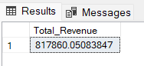

**2. Average Order Value**

SELECT (SUM(total_price) / COUNT(DISTINCT order_id)) AS Avg_order_Value FROM pizza_sales

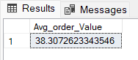

**3. Total Pizzas Sold**

SELECT SUM(quantity) AS Total_pizza_sold FROM pizza_sales

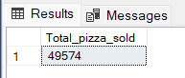

**4. Total Orders**

SELECT COUNT(DISTINCT order_id) AS Total_Orders FROM pizza_sales

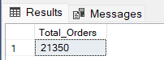

**5. Average Pizzas Per Order**

SELECT CAST(CAST(SUM(quantity) AS DECIMAL(10,2)) /

CAST(COUNT(DISTINCT order_id) AS DECIMAL(10,2)) AS DECIMAL(10,2))

AS Avg_Pizzas_per_order

FROM pizza_sales

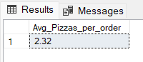

**CHART REQUIREMENTS**

**B. Daily Trend for Total Orders**SELECT DATENAME(DW, order_date) AS order_day, COUNT(DISTINCT order_id) AS total_orders

FROM pizza_sales

GROUP BY DATENAME(DW, order_date)

***Output:***

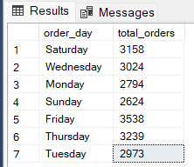

**C. Monthly Trend for Orders**

select DATENAME(MONTH, order_date) as Month_Name, COUNT(DISTINCT order_id) as Total_Orders

from pizza_sales

GROUP BY DATENAME(MONTH, order_date)***Output***

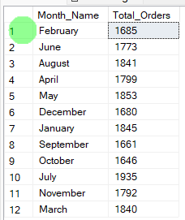

**D. % of Sales by Pizza Category**

SELECT pizza_category, CAST(SUM(total_price) AS DECIMAL(10,2)) as total_revenue,

CAST(SUM(total_price) * 100 / (SELECT SUM(total_price) from pizza_sales) AS DECIMAL(10,2)) AS PCT

FROM pizza_sales

GROUP BY pizza_category

***Output***

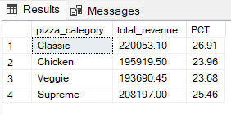

**E. % of Sales by Pizza Size**

SELECT pizza_size, CAST(SUM(total_price) AS DECIMAL(10,2)) as total_revenue,

CAST(SUM(total_price) * 100 / (SELECT SUM(total_price) from pizza_sales) AS DECIMAL(10,2)) AS PCT

FROM pizza_sales

GROUP BY pizza_size

ORDER BY pizza_size

***Output***

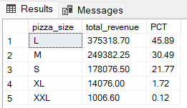

**F. Total Pizzas Sold by Pizza Category**

SELECT pizza_category, SUM(quantity) as Total_Quantity_Sold

FROM pizza_sales

WHERE MONTH(order_date) = 2

GROUP BY pizza_category

ORDER BY Total_Quantity_Sold DESC

***Output***

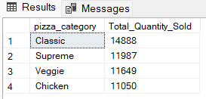

**G. Top 5 Pizzas by Revenue**

SELECT Top 5 pizza_name, SUM(total_price) AS Total_Revenue

FROM pizza_sales

GROUP BY pizza_name

ORDER BY Total_Revenue DESC

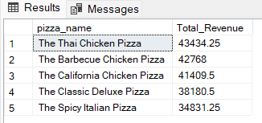

**H. Bottom 5 Pizzas by Revenue**

SELECT Top 5 pizza_name, SUM(total_price) AS Total_Revenue

FROM pizza_sales

GROUP BY pizza_name

ORDER BY Total_Revenue ASC

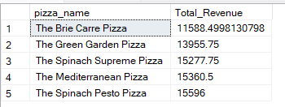

**I. Top 5 Pizzas by Quantity**

SELECT Top 5 pizza_name, SUM(quantity) AS Total_Pizza_Sold

FROM pizza_sales

GROUP BY pizza_name

ORDER BY Total_Pizza_Sold DESC

***Output***

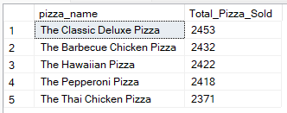

**J. Bottom 5 Pizzas by Quantity**

SELECT TOP 5 pizza_name, SUM(quantity) AS Total_Pizza_Sold

FROM pizza_sales

GROUP BY pizza_name

ORDER BY Total_Pizza_Sold ASC

***Output***

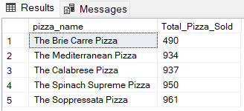

**K. Top 5 Pizzas by Total Orders**

SELECT Top 5 pizza_name, COUNT(DISTINCT order_id) AS Total_Orders

FROM pizza_sales

GROUP BY pizza_name

ORDER BY Total_Orders DESC

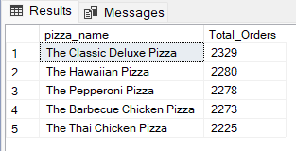

**L. Bottom 5 Pizzas by Total Orders**

SELECT Top 5 pizza_name, COUNT(DISTINCT order_id) AS Total_Orders

FROM pizza_sales

GROUP BY pizza_name

ORDER BY Total_Orders ASC

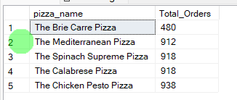

--------------------------------------------------------------------------

NOTES:

CLEANING DATA FIRST

First get the raw data and clean it as per the requirements, edit the headers, remove nulls, replace empty values and create a good cleaned file

IMPORTING DATA INTO SSMS - SQL SERVER MANAGEMENT SYSTEM

Create database

Connect to the database

Import flat file into the tables fix the datatypes

Go to tables and add the table and refresh

Open the query tool and test your database

Once all set, run your sql queries there. And try to match the business requirement outputs there in the mysql workbench.

BUILDING DASHBOARDS

Come to power bi, before you could build any dashboard, there is always a need to clean data

So get your data from sql server

Open in in power bi

Go to your data tab

Click transform data and open the power query

Now clean your data here

Remember you can always come back to power query to edit the data and add the necessary columns for your reports and charts

Then as usual you can create charts by drag and drop the required columns in them.